September Board Meeting Minutes of LIFE Prep

Date: September 16, 2025
Time: 5:00 p.m.
Location: LIFE Prep School: 930 Geranium Avenue East, St. Paul, MN 55106
Members may also be participating by interactive technology

Members present: Nou, Christine, Gillian, Katye, Beth, Madison, Darla, Leah and Brittany via interactive technology
Also present: Kelsey, Christyna
Members not in attendance: Katie

Called to order at 5:16 by Nou

Agenda:
- Conflict of Interest
    - None
- Consent Items:
  - Review/approve August 2025 minutes
    - Gillian
    - Darla
  - Review/approve September 2025 agenda
    - Madison motions
    - Beth seconds
- Authorizer Communication – (The Guild)
    - None
- Executive Committee Report - Nou
    - Discussed board structure regarding Samantha’s requested leave of absence due to medical reasons and whether the board would like to vote to
    - Discussed active committees and members
    - Also discussed the required 25 hours of professional development that Leah and Christyna will be completing this year and how the board will be assisting with that list of professional development choices
    - Lastly, discussed that Nou will be resigning after this meeting and any members with interest in
- Policy Committee Report – Christine/Kelsey/Christyna
    - After further review of the attendance policy and going through the first two weeks of school, it was noticed that there was not qualifying minutes to designate when a half day absence would take effect rather than a tardy
    - After reviewing other schools policies around this, it was decided that 15 minutes was the best
    - When students arrive late or leave early, it will be recorded as a half day unexcused/excused absence and Ms. Lori has been recording the time as well so that the attendance committee can see trends and how much of the school days are missed
    - Parents will be notified of this policy change if approved
- Finance Committee Report-
    - Balance Sheet:
      - Highlights:
        - Reconciled cash balance as of the end of the month $206, 762
        - Current line of credit balance is $0
    - Income statement:
      - Highlights:
        - Percent of Fiscal year completed: 17%
        - YTD revenue as a percentage of the approved revised budget: 12%
        - YTD expenses as a percentage of the approved revised budget: 7%
    - Audit: Annual audit is scheduled for the week of Sept. 22nd. At this point the numbers on the June Financial statements have not been finalized for the year end. Over the next couple months, the FY25 accruals will be finalized and entered in preparation for the annual audit. This will include finalizing the FY25 holdback numbers and salaries payable for FY25 along with other misc. Revenues and expenditures.
- Executive Director’s Report – Leah
    - Current enrollment is 131 with pre-k
      - Pre-k: 18 reached out to families this week
      - K: 14
    - Average daily membership: 123.4
    - Trends/Changes:
    - Academic Progress & Curriculum
      - Recent Assessments/Results:
      - FAST testing began on Sept. 9th. Testing will be completed by the 26th.
      - CAPTI testing will start for 4th- 6th after FAST is completed. This is only students flagged for high risk (roughly 35-38 students). This is not required to start in the fall. It is required to start in the winter. However, we will work to get it started as quickly as possible.
      - Curriculum updates:
      - UFLI was purchased for SpEd. We will purchase another for EL.
      - Upcoming initiatives:
      - Organizing staff committees (ILT, student council, yearbook, etc.)
    - Staffing and Professional Development
      - 1st and 2nd grade were split and Ms. Sophie is teaching 2nd grade.
      - Three new paras were hired. May need 1 more depending on upcoming evaluations.
    - Student Support and Well-being
      - Counseling and Mental Health Services
        - Law will require mental health services for all schools at the start of the 26/27 school year.
        - No discipline and behavior trends at this time.
        - Parent/Guardian Engagement:
        - Recently had a family interested in volunteering in the classroom, Leah is in the process of creating a volunteer agreement.
    - Professional Development Highlights:
      - All staff have been trained in CPI and first aid.
      - Leah attended online PD related to board development on 9/16/25
      - Ms. Christyna will be attending Homeless Liaison training in October.
    - Facilities and Operations
      - Building and grounds:
        - Spoke with the landlord about safety upgrades. They have asked for an estimate .
        - Landlord has gotten a few bids for artificial turf for the playground. Leah is working with the church on how we will move forward.
        - Jon McKinna has been working with the church and Leah in detail in regards to both safety of the building and playground details
        - Fire safety month is in October
    - Community and Partnerships
      - Community Events
        - None scheduled this for this month
        - Oct. award assembly is on October 31st.
      - Partnerships
        - HY-VEE donated school supplies
    - Budget and Finance Overview
      - Current budget status
      - Funding updates
        - Will likely be applying for a Health and Wellbeing grant this month
      - Expenditures
        - None at this time
    - Celebrations and Recognitions
      - Teachers dove right into curriculum and there was lots of learning right from the start
      - Buses are on time and doing well. The year had a smooth, calm start.
    - Challenges and Needs
      - Finding substitutes- TOC is no longer in operation. We are now using ZEN Educate. According to them, they have a 97% fulfillment rate.
      - Obviously- playground
      - Need a school Social Worker
    - Looking Ahead
      - Short-term goals
        - Creating more informative grade cards based on standards. ILT is working on this
      - Long-term goals
        - Strategic planning costs. How will the board move forward with this process?
    - Conclusion
      - This year is off to a great start. I look forward to continuing to work on enrollment and with committees of the board.
- Goals Review-
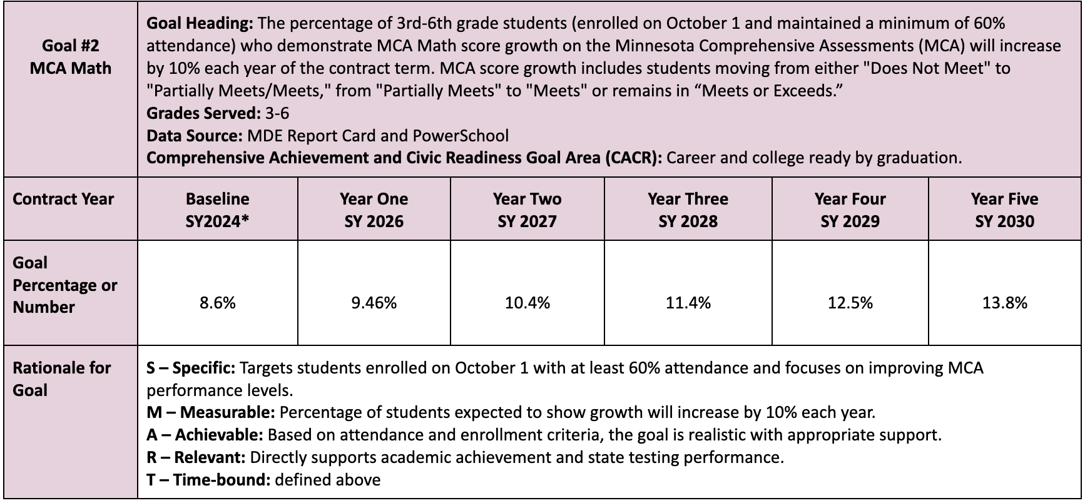
- MCA tests are taken in April/May and the final scores are received the following August. Therefore, we will not have data on this goal until September 2026 to review.

- Public Communication to the Board
    - None
- Board Actions
  - Financial Packet for August 2025
    - Discussed Auditor/Board Training in the Income Expense Statement noting an expense of $8,420. Kelsey and Leah will ask Dawn if this is a prepayment for the upcoming au
    - Christine motions
    - Gillian seconds
  - Review and discuss language and potential amendments to Attendance Policy
    - Reviewed and discussed during policy committee update
    - Brittany motions
    - Kayte seconds
  - Address and vote on board member leave of absence
    - Clarified that a leave would make her a non-active/non-voting member
    - Roll call vote Gillian- yes, Kayte- yes, Christine- yes, Nou- yes, Brittany- yes, Beth-yes, Madison-yes, Darla- yes.
    - Vote is unanimous

Finally, discussed and scheduled committee meetings:
Executive- 4:00 on the 3rd Monday of the month.
Finance- TBD
Policy- TBD
Community outreach- 1st Friday of each month, 5:00
Attendance: Communication happens every 2 weeks when reports come out and members meet then

Beth will be in charge of submitting the agenda and meeting minutes to The Buddy System

Adjournment at 6:32 by Nou
Darla motions
Gillian seconds

Next regular board meeting: Tuesday, October 21, 2025

